**STRING:**

A string is a sequence of characters inside either in single quotes,double quotes or triple quotes.Strings are immutable.

**METHODS IN STRINGS**:

#### Capitalize():This method converts first character of a string to uppercase letter and other characters into lowercase letter.

#### Syntax:string.capitalize()

#### Screenshot (356).png

#### Title():This method returns a string with first letter of each word capital.

#### Syntax:string.title()

#### Screenshot (357).png

#### lower(): This method converts all uppercase characters in a string into lowercase characters.

#### Syntax:string.lower()

#### Screenshot (358).png

#### Upper():This method converts all lowercase characters in a string into uppercase characters.

#### Syntax:string.upper()

#### Screenshot (359).png

#### swapcase():This method converts all uppercase characters to lowercase and all lowercase characters to uppercase characters of the given string,

#### Syntax:string.swapcase()

#### Example:

#### Screenshot (203).png

#### index() :This method returns the index of a substring inside the string (if found). If the substring is not found, it raises an exception.

#### Syntax:string.index()

#### Screenshot (360).png

#### Count():This method returns the number of occurrence of a substring in a given string

#### Syntax:string.count()

#### Example:

#### Screenshot (361).png

#### find():This method returns the index of first occurrence of the substring (if found).

#### Syntax:string.find()

#### Screenshot (362).png

split():The  method splits a string into a list and also specify the separator, default separator is whitespace.

Syntax:string.split()

Example:

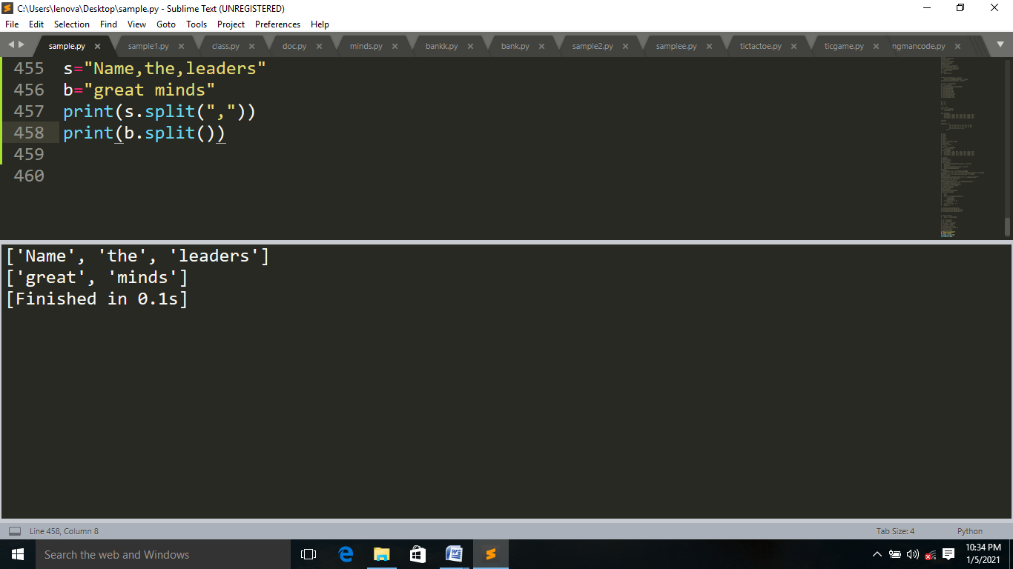

strip():This method() remove spaces at the beginning and at the end of the string.

Syntax:string.strip()

Example:

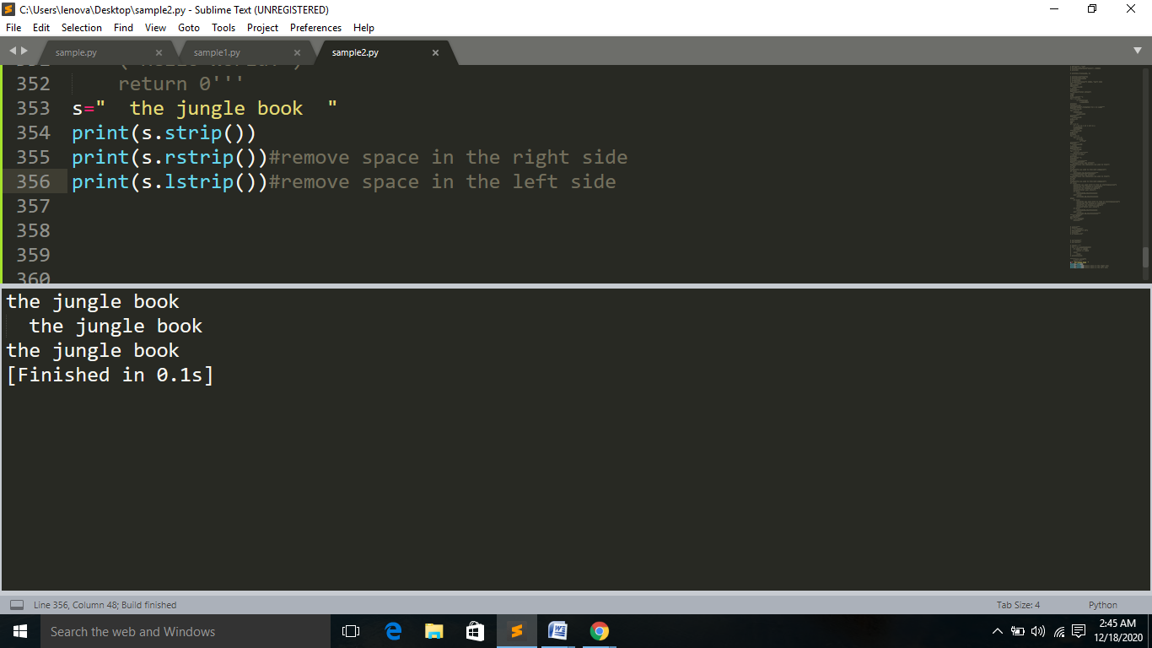

#### join():This method returns a string by joining all the elements of an iterable, separated by a string separator.

#### Syntax: separator.join()

#### Example:

#### Screenshot (209).png

#### Screenshot (365).png

Startswith():This  method returns a boolean.It returns True, if the string starts with the specified prefix.It returns False, if the string doesn't start with the specified prefix.

Syntax:string.startswith()

 endswith():This  method returns a boolean.It returns True if strings ends with the specified suffix.It returns False if string doesn't end with the specified suffix.

Syntax:string.endswith()

Example:

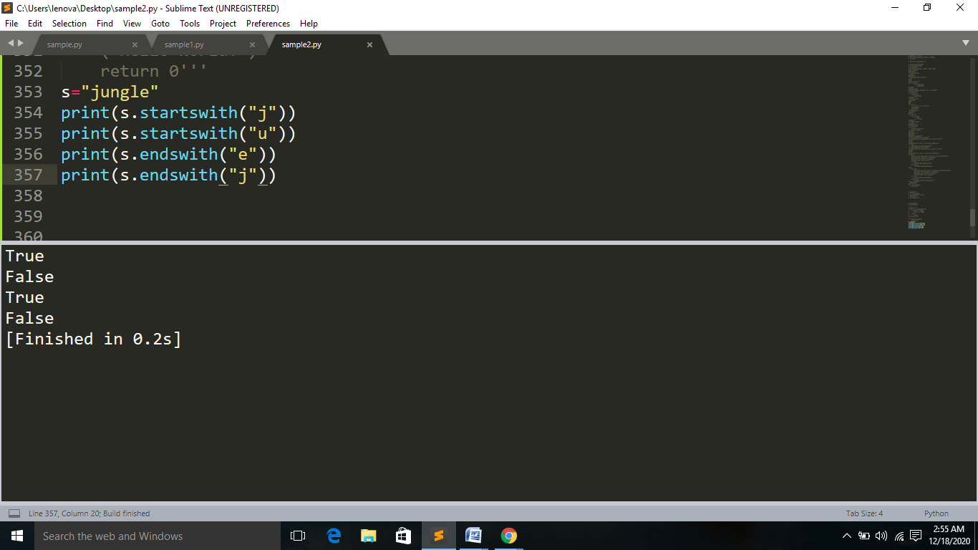

 replace():This method returns a copy of the string where the old substring is replaced with the new substring. The original string is unchanged.

syntax:string.replace(‘ ‘,’ ‘)

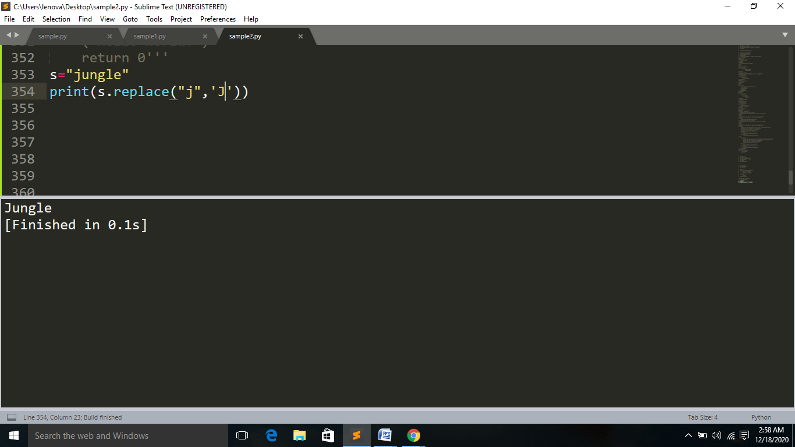

ljust():This method will left align the string,using a specified character(space is default)as the fill character.

Syntax:string.ljust()

rjust():This method will right align the string,using a specified character(space is default)as the fill character.

Syntax:string.rjust()

Example:

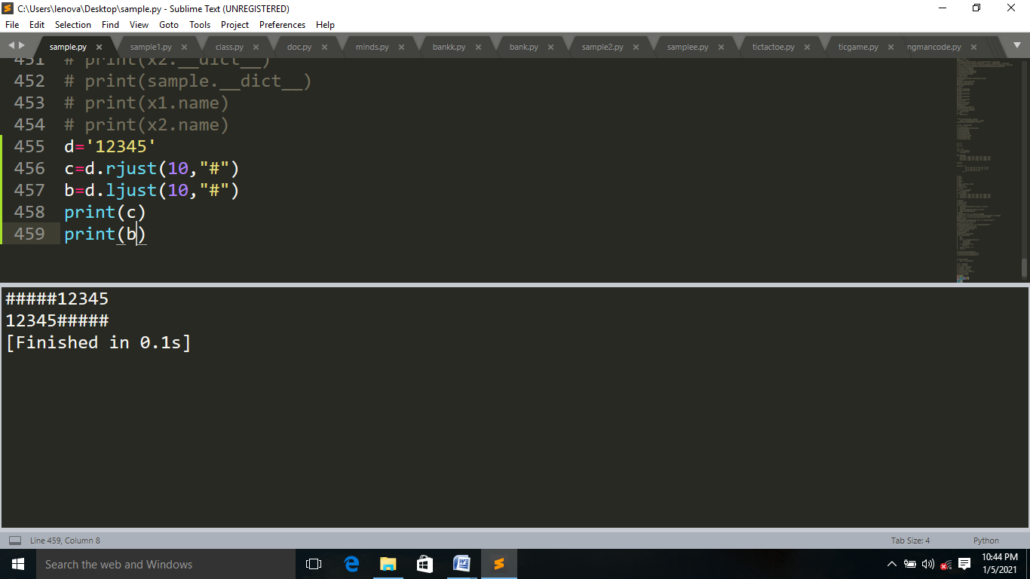

format() :This method takes any number of parameters. But, is divided into two types of parameters:

* **Positional parameters** - list of parameters that can be accessed with index of parameter inside curly braces {index}
* **Keyword parameters** - list of parameters of type key=value, that can be accessed with key of parameter inside curly braces {key}

**Example:**

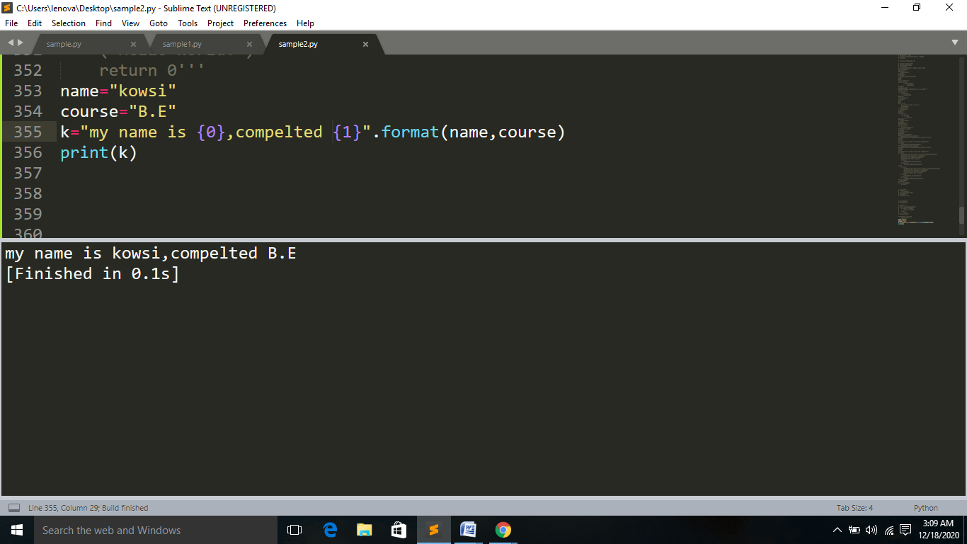

#### islower() :This method returns true if all alphabets in a string are lowercase alphabets. If the string contains at least one uppercase alphabet, it returns False.

#### Syntax:string.islower()

isupper():This method returns true if all characters in a string are uppercase characters,false if any characters in a string are lowercase characters.

Syntax:string.isupper()

  istitle():This  method returns true if the string is a titlecased string and false if the string is not a titlecased string or an empty string.

Syntax:string.istitle()

 isdigit(): This method returns true if all characters in the string are digits,false if at least one character is not a digit.

Syntax:string.isdigit()

isalpha():This method returns true if all characters in the string are alphabets (can be both lowercase and uppercase) and false if at least one character is not alphabet.

